

**Dynamic General Equilibrium Model for Climate Resilient Economic Development (DGE-CRED)**

Installation and Execution Manual

with Practical Exercises

Global Programme "Policy Advice for Climate Resilient Economic Development" (CRED)

Halle (Saale), December 2021

**Table of Contents**

1 About this Manual 3

2 List of Video Tutorials 3

3 Dynare 4

3.1 On Windows 4

3.2 On macOS 8

4 DGE-CRED Model 12

4.1 Downloading the DGE-CRED model 12

4.2 DGE-CRED model Files 13

4.2.1 ModFiles 13

4.2.2 Functions 13

4.3.1 ExcelFiles 13

4.3 Model Simulations 14

4.4 Create Customized Scenarios 19

5 Sectoral damages and adaptation measures 24

5.1 Calibration 24

5.2 Climate Scenarios 24

5.3 Agriculture Sector 25

5.4 Forestry sector 26

5.5 Housing sector 26

5.6 Transport sector 27

6 Practical session 28

6.1 Practical Session 1 28

*6.2* Practical Session 2 36

6.3 Practical Session 3 39

6.4 Practical session 4 42

6.5 Practical session 5 43

7 Appendix 46

7.1 MATLAB Functions 46

# About this Manual

This manual is intended to guide you through the process of using the DGE-CRED model step by step, from installing the different software needed to executing model simulation to designing and implementing customised scenarios. Furthermore, a section of the manual includes practical exercises so that the user can gain a deeper understanding of how to change variables, run different scenarios and interpret results. No prior experience with *Dynare* or *MATLAB* is needed.

The resources of this manual include written descriptions of each step combined with pictures and diagrams that will help the user understand how to operate the Model. Also, a series of *YouTube* video tutorials has been developed to provide a more detailed description of certain sections. A link to each video is provided at the beginning of the sections, which include it. Furthermore, all the videos can be accessed in the next section, which includes a complete list of the tutorials. The videos are intended to be followed in order as they appear in the list.

To use the DGE-CRED Model, you will need *Dynare* (at least version 4.6.1) and MATLAB (at least 2018b). While it was possible to run previous versions of the Model on the open-source software Octave, the current version does not admit Octave. Thus, we recommend using MATLAB to simulate the Model smoothly and avoid high computational costs. Additional software needed for the Model includes MS Excel, used to specify parameters and save the results. Furthermore, results tables are saved in LaTeX format.

# List of Video Tutorials

A list of all the video tutorials that accompany the manual can be found below. You can access them by clicking on the different items.

* [Installing Dynare on Windows](https://youtu.be/diBSjzkVZI8)
* [Installing Dynare on MacOS](https://youtu.be/9PbVWZiQ6A4)
* [Downloading the DGE-CRED model files](https://youtu.be/UcoVPpes198)

# Dynare

## On Windows

A video tutorial of the installation of *Dynare* on Windows can be accessed [here](https://youtu.be/diBSjzkVZI8).

1. Go to <https://www.dynare.org/download/> in your internet browser. **(1)** In the windows tab, **(2)** click on one of the download package options and wait until the downloading process is completed.

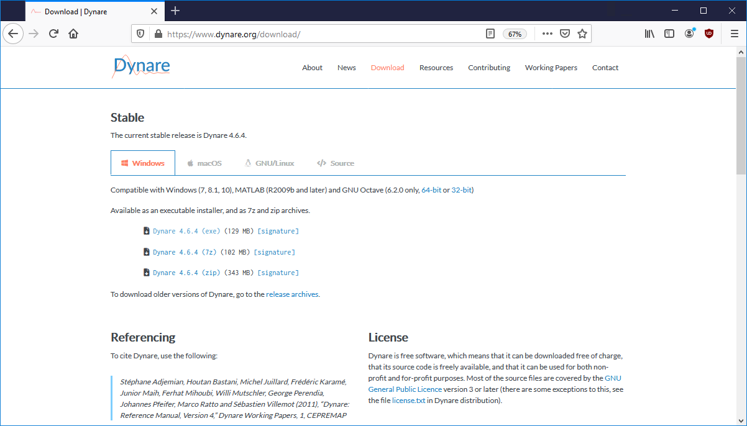

1

2

1. Select the *Dynare* package file from the downloads folder. You must allow Dynare to make changes on your device in order to install it.
2. In the installer window, click on 'Next'.

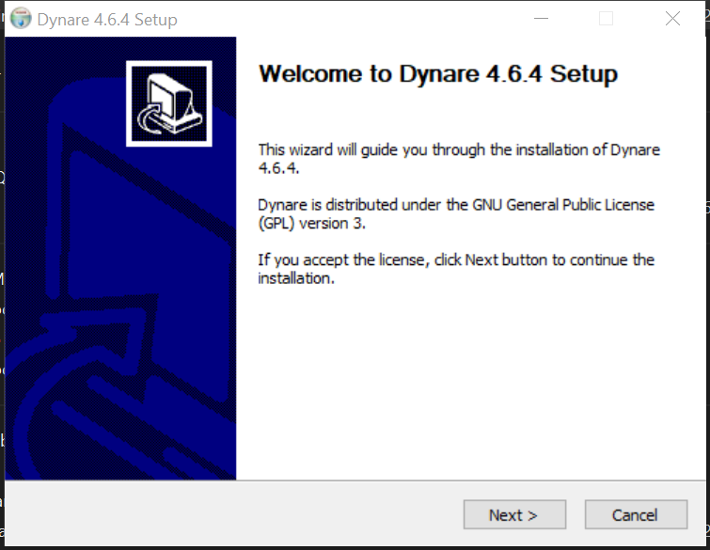

1. **(1)** Select the components you would like to install, depending on whether your MATLAB or Octave is 32 or 64-bit. If unsure, select both. Then, **(2)** click on next.

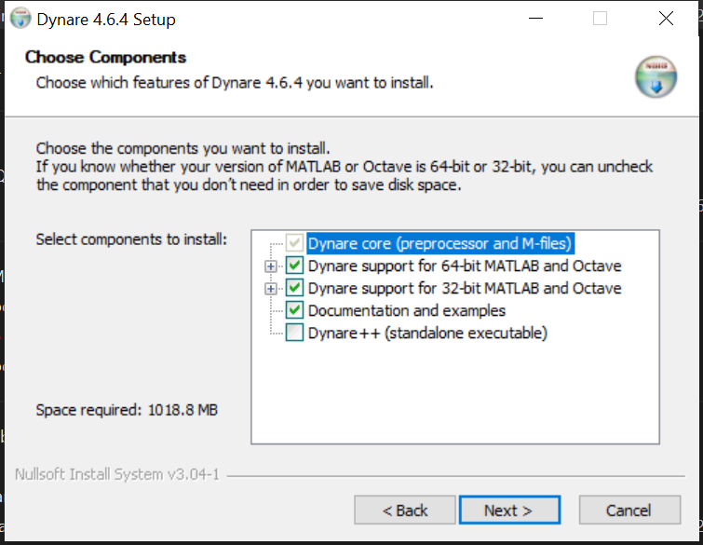

1

2

1. *Dynare* will be installed in your default disc unless otherwise indicated. You may specify a different location by **(1a)** typing or **(1b)** browsing a new directory. To begin with the installation, **(2)** click on 'install.'

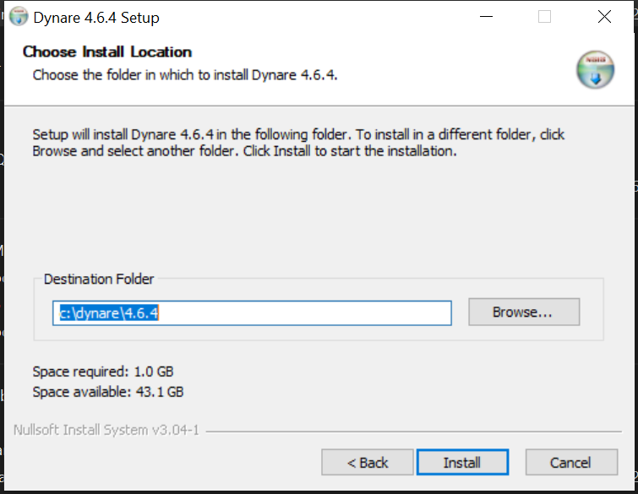

1b

1a

2

1. 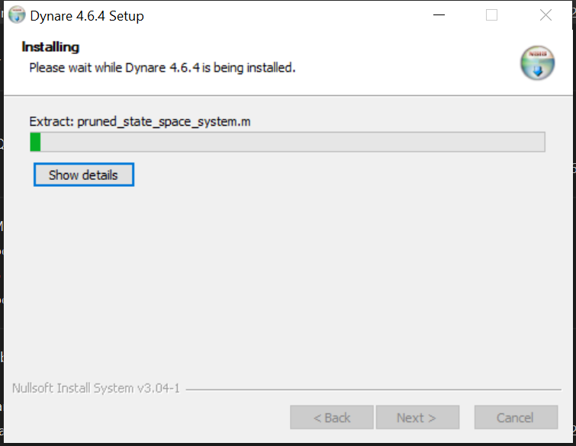You may check the installation process in the resulting window.
2. Once the installation has been completed, click on 'Finish.'

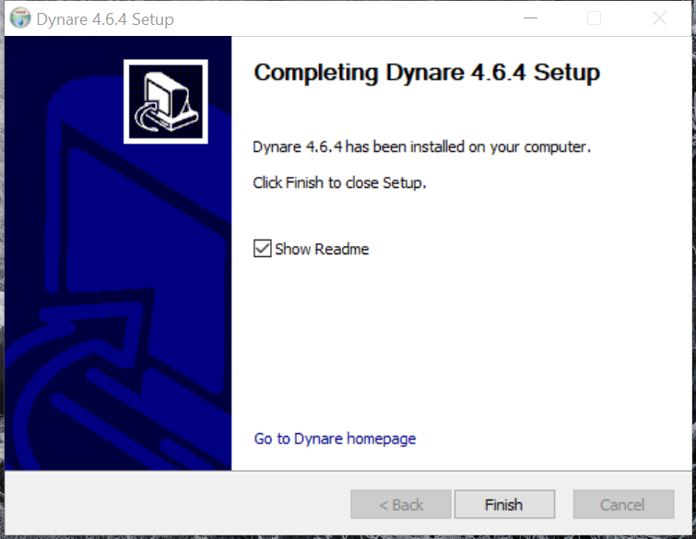

1. The installation of *Dynare* is completed.

## On macOS

A video tutorial of the installation of *Dynare* on macOS can be accessed [here](https://youtu.be/9PbVWZiQ6A4).

1. Go to <https://www.dynare.org/download/> in your internet browser. (1) In the macOS tab, (2) click on the pkg file and wait until the downloading process is completed.
2. Select the dynare-4.x.y.pkg file from the downloads folder, where 4.x.y is the Dynare version you downloaded.

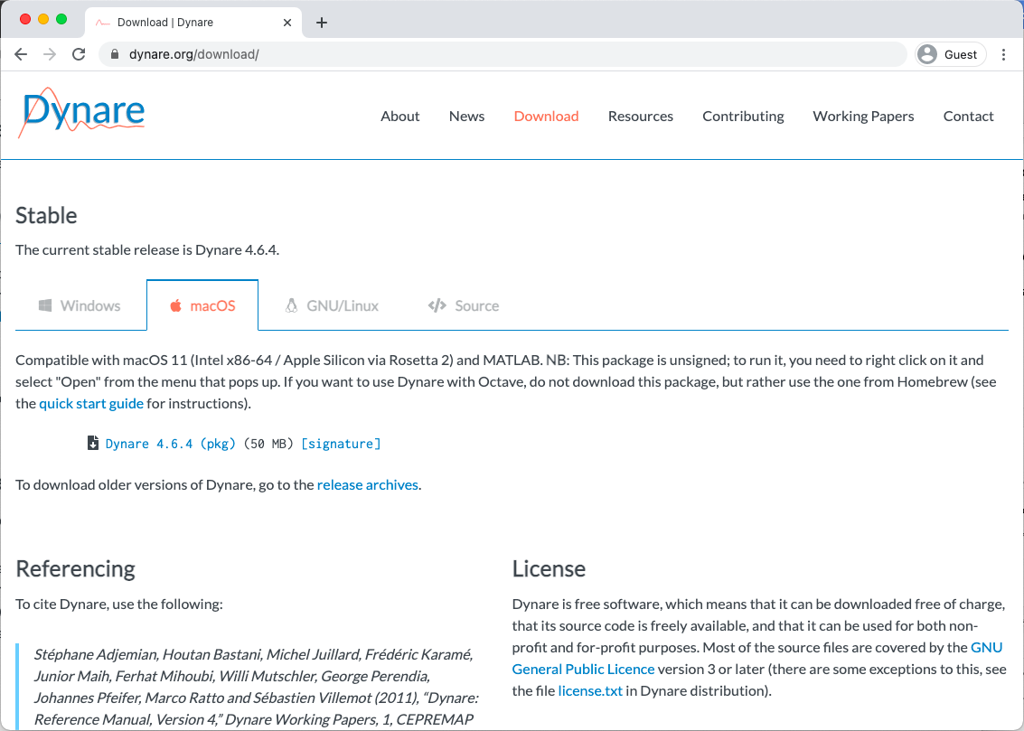

1

2

1. If your computer cannot open dynare-4.x.y.pkg because it is from an unidentified developer, continue with the next item. Otherwise, skip to item 5.
2. Go to System Preferences -> Security & Privacy. In the General tab, click on 'Open anyway.'
3. On the Dynare Installer window, click 'Continue.'

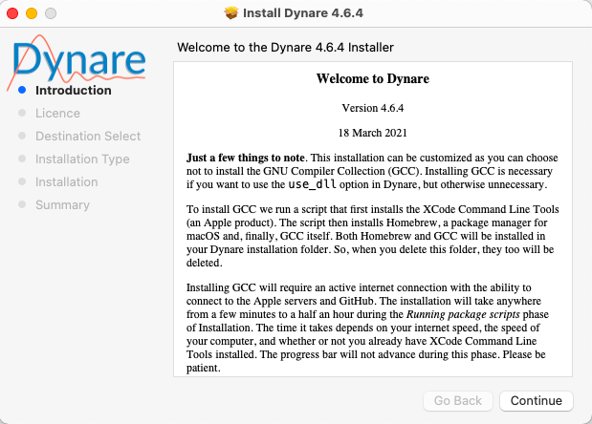

1. Review the GNU General Public License and **(1)** select '*Continue*.' A window will pop up. **(2)** To continue, you must click on '*Agree*.' You may click on '*Read Licence'* to access the license agreement before continuing with the installation.

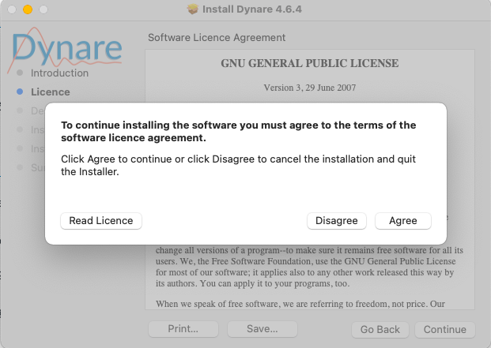

2

1

1. *Dynare* will be installed in your computer's default disk unless otherwise indicated. You can specify a different location by **(1)** clicking on '*Change Install Location'* and selecting your preferred disk. To proceed with the installation, **(2)** click on '*Install*.'

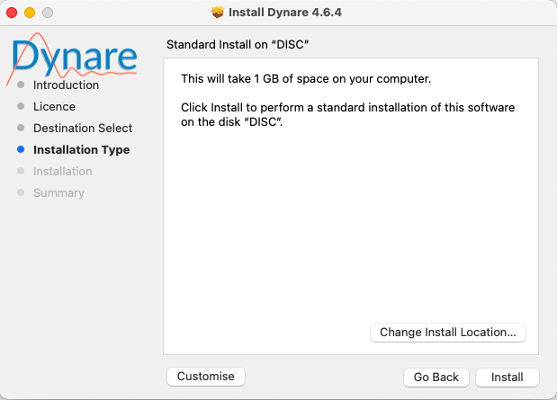

1

2

1. 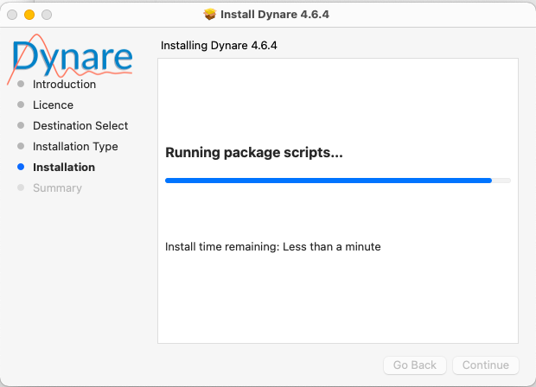You will be required to introduce the user's password to proceed with the installation. The installation will start automatically when the password is introduced correctly. You may check the installation progress and the remaining time in the resulting window.
2. 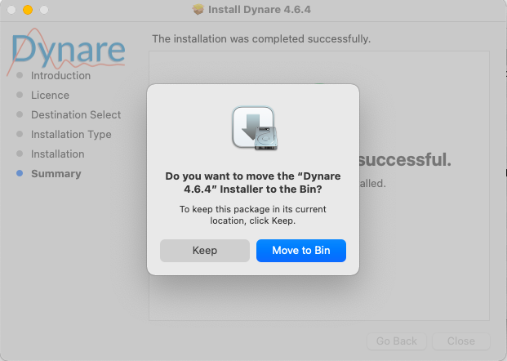Once the installation has been completed successfully, click on '*Close*.' You may move the installation package to the bin to save space on your computer. To do so, select '*Move to Bin.*'
3. The installation of *Dynare* is completed.

# DGE-CRED Model

## Downloading the DGE-CRED Model

A video tutorial of the downloading of the model files can be accessed [here](https://youtu.be/UcoVPpes198).

1. Go to <https://github.com/schultkr/DGE-CRED> in your internet browser to access the DGE-CRED repository in GitHub. **(1)** Click on the 'Code' button and **(2)** select 'Download ZIP' to download the files in .zip format. You can skip this step if you already have the zip folder.

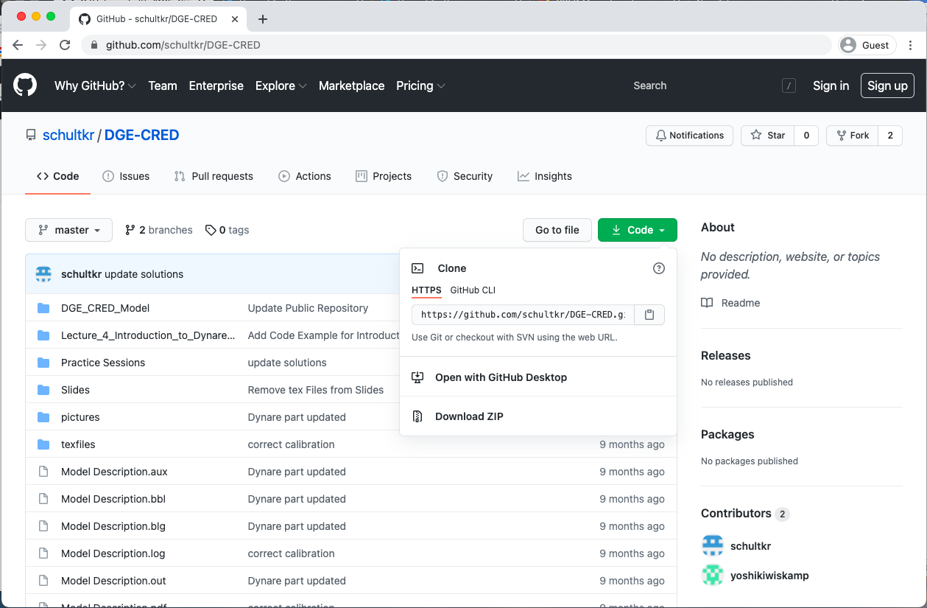

1

2

1. Open the DGE-CRED-master.zip file from the downloads folder to unzip it.

## DGE-CRED model Files

The following subfolders can be accessed via *DGE-CRED-master/DGE_CRED_MODEL*.

### ModFiles

***RunSimulations.m*** defines the different scenarios and contains a call to ***DGE_CRED_Model.mod***, which is used to adjust the number of productive sectors and regions to be included in the simulation. This .mod file also includes a call to the following files stored in the *ModFiles* folder

1. ***DGE_CRED_Model_AuxiliaryVaribles.mod***defines climate shocks as well as productivity shocks.
2. ***DGE_CRED_Model_Declaration.mod*** declares all endogenous and exogenous variables and structural parameters of the Model.
3. ***DGE_CRED_Model_Equations.mod*** contains the equations of the Model.
4. ***DGE_CRED_Model_LatexOutput.mod*** produces *LaTeX* output for documentation of the declared variables and model equations.
5. ***DGE_CRED_Model_Parameters.mod*** assigns values to the structural parameters of the Model.

### Functions

The following programs are responsible for finding initial and terminal conditions. A more detailed description of this program is included in the *Appendix*

1. ***Calibration.m*** finds the initial conditions to reflect a specific year.
2. ***FindK.m*** looks for a capital allocation across sectors and regions to fulfil the static equations of the Model.
3. ***SteadyState.m*** a Matlab script to find the initial steady state of the Model and to calibrate it. It calls the function ***Calibration.m.***
4. ***Simulation.m*** is a Matlab script to run the perfect foresight solver in small steps and differently for the Baseline and climate change scenarios. It uses the ***FindK.m*** function.

### Auxiliary

The following programs are necessary to run the Model. The scripts and functions are called during the simulation of the Model.

1. ***AssignPredeterminedVariables.m*** defines predetermined variables of the Model to find the new steady state. The function is called by DGE_CRED_Model_steadystate.mat.
2. ***ChangeModFile.m*** changes the DGE_CRED_Model.mod file during the simulation. It allows changing the number of sectors and regions and whether productivity is endogenous or exogenous.
3. ***ComputeAggregates.m*** computes aggregate variables from regional and sectoral levels for the steady-state computation. The function is called by DGE_CRED_Model_steadystate.mat.
4. ***DefineAuxiliaryExpressions.m*** defines integer arrays with the position of endogenous, exogenous variables and parameters in the dynare model and results structure. The arrays are used to update the respective dynare structures during the simulation.
5. ***LoadExogenous.m*** reads in the exogenous variables for each scenario and updates the dynare structures.
6. ***LoadGrowthRates.m*** reads in the growth rates for the baseline scenario.
7. ***TaxIncome.m*** computes the tax income in the steady-state for the Model. The function is called by DGE_CRED_Model_steadystate.mat.

### Miscellaneous

The programs contained in this folder are used to define Excel input files for simulations, even though they are not necessary for the model simulation itself. Please refer to each file individually to understand its purpose.

### ExcelFiles

This subfolder contains data and results for different simulations with K sectors and R regions. ***ModelSImulationandCalibrationKSectorsandRRegions.xlsx*** includes the following sheets

1. *Content* includes links and descriptions for all the sheets in the file. Additionally, it maps the different regions and subsectors to their associated reference numbers.
2. *Data* contains calibration values for all the sectors in each region as well as for climate variables.
3. *Start* includes initial values for the model variables of all sectors in each region.
4. *Structural Parameters* defines the model parameters for all sectors in each region.
5. *Baseline* contains the path for exogenous variables in the baseline scenario.
6. *SSP585* contains the path for exogenous variables in the high development pathway.
7. *SSP126* contains the path for exogenous variables in the green development pathway.

Furthermore, ***ResultsScenariosKSectorsandRRegions.xlsx*** stores the simulation results in the scenario sheets defined above.

## Model Simulations

1. Initiate *MATLAB* and open ***DGE_CRED_Model*** file, located in the ***DGE_CRED-master***. You can navigate the file browser to find this directory.

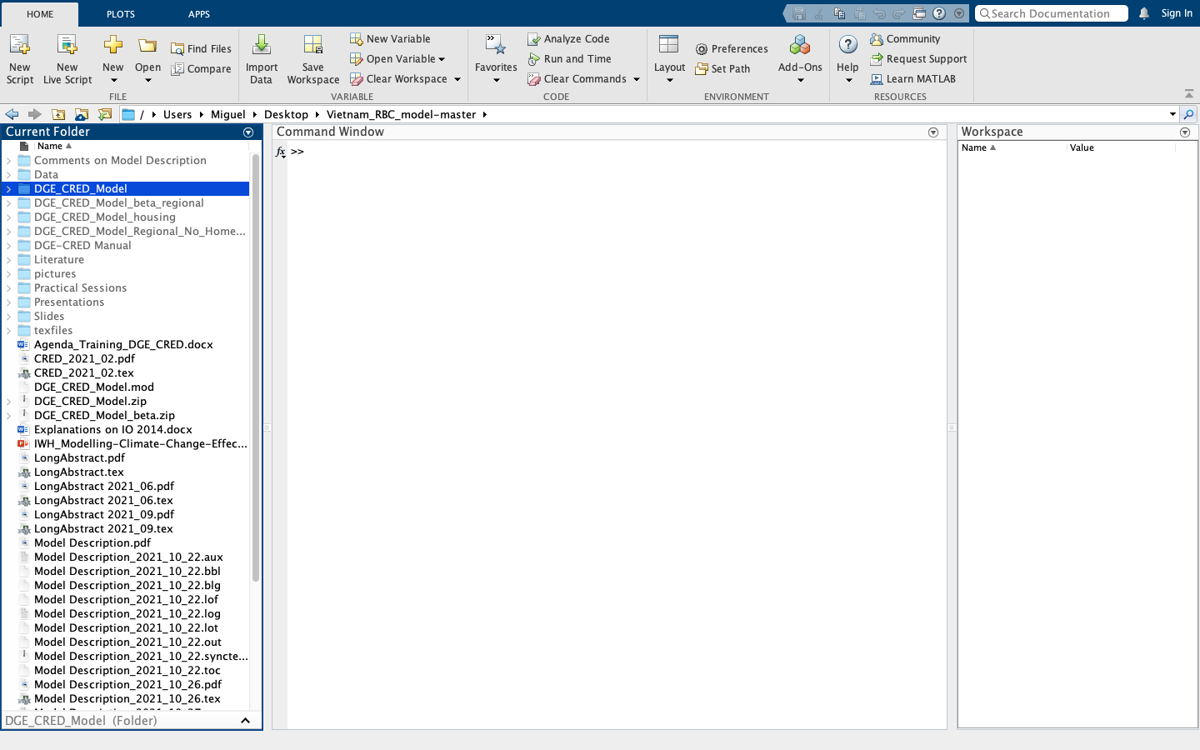

c

c

1. Find the ***DGE_CRED_Model.mod*** file and **(1)** click on it to open it. While this file does not need to be modified before executing the program, it allows the user to set different simulation parameters.
2. For instance, Next, the user can **(2)** determine whether agents in the Model use rational expectations or form their expectations based on the previous period by setting line 7 of the *.mod* file to *'@# define ForwardLooking = 1'* or *'@# define ForwardLooking = 0'*, respectively.

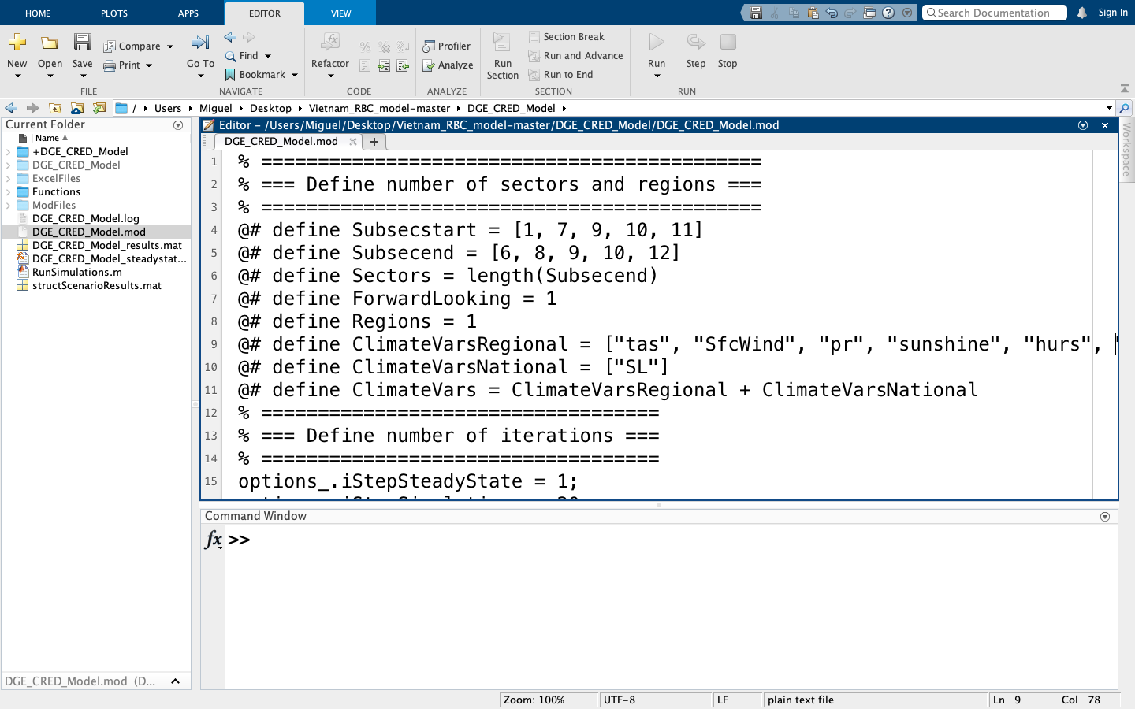

2

1

1. An additional feature of this *.mod* file allows the user to define the climate variables that will be included in the Model. **(1)** The climate variables that affect the economy at the regional level can be defined by setting line 9 of the *.mod* file to '@# define ClimateVarsRegional = [ ]' with the particular climate variables you would like to include separated by a comma inside the brackets. These are the commands for climate variables at the regional level.

* "tas" accounts for changes in surface temperature.
* "SfcWind" accounts for changes in surface wind speed.
* "pr" accounts for changes in precipitation.
* "sunshine" accounts for changes in hours of daily sunshine.
* "hurs" accounts for changes in relative surface humidity.
* "heatwave" accounts for changes in the number of yearly heatwaves.
* "maxdrydays" accounts for changes in maximum consecutive dry days in a year.
* "maxwetdays" accounts for changes in maximum consecutive wet days in a year.
* "storms" accounts for changes in the number of yearly storms.
* "floods" accounts for changes in the number of yearly floods.
* "fires" accounts for changes in the yearly burned area.
* "landslide" accounts for changes in the number of yearly landslides.

**(2)** Line 10 of the .mod file can be modified to account for changes in the sea level nationally. To do so, set it to *‘@# define ClimateVarsNational = [ “SL” ].’* Once you have adjusted the *.mod* file, **(3)** save the file by either clicking on the '*Save'* icon in the menu bar or pressing *Command + S*.



2

1

3

1. **(1)** Open the **RunSimulations.m** file. **(2)** Line 5 of the .*m* file should be set according to the *Dynare* version installed in your computer, as well as the operating system.

*The program is set to run on Windows by default*. Therefore, if using *Windows*, you just need to make sure that line 5 includes the appropriate *Dynare* version. For instance, if you installed *Dynare* 4.6.3, line 5 should be set to '*addpath('C:\dynare\4.6.3\matlab').*'

*To execute the program on macOS*, you must set line 6 of the .*m* file to '﻿*addpath('/Applications/Dynare/4.x.y/matlab')*', where 4.x.y is the *Dynare* version installed on your computer.

Furthermore, the simulation of different scenarios is achieved by **(3)** modifying line 8 of the *.m* file to *'casScenarioNames = { }'* with any combination of the following commands separated by a comma inside the curly brackets.

* "Baseline" only accounts for population growth following the medium GSO projection, which forecasts an increase of the Vietnamese population from 95 million people in 2016 to 108 million by 2050. After 2050, the population will stay constant.
* "SSP126" represents the low end of the range of plausible future pathways, depicting the 'best case' future from the sustainability perspective. In this sense, global greenhouse gas emissions evolve such that low radiative forcing (2.6 W/m2) is achieved by 2100.
* "SSP585" represents the high of plausible future pathways, with emissions high enough to produce 8.5 W/m2 level of radiative forcing by 2100.

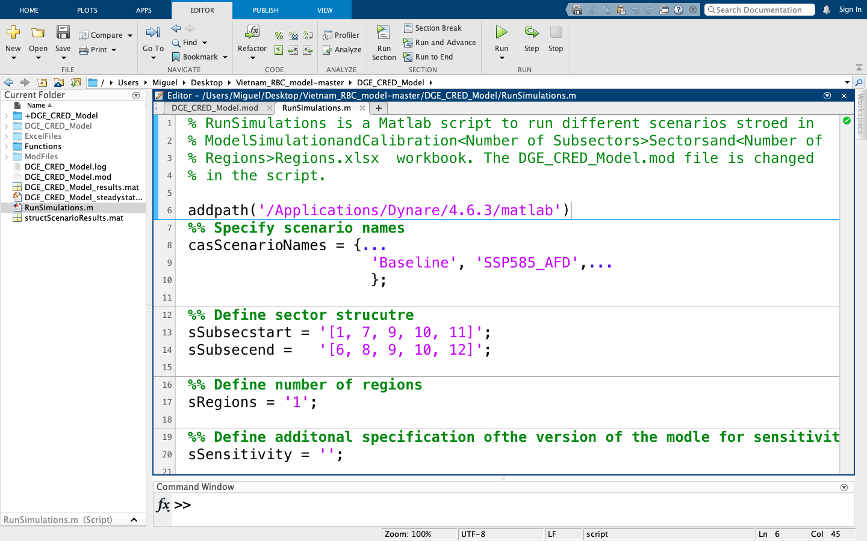

1

2

3

1. Furthermore, the ***RunSimulations.m*** allows for adjusting the number of sectors and subsectors by modifying lines 13 and 14. The Model considers a maximum of five sectors; 1) Basics, 2) Construction and manufacturing, 3) Transport water, 4) Transport Land, and 5) Services and Health. The number of sectors is given by the length of the vectors in lines 13 and 14, which must be the same.

These sectors include subsectors, which can be broken down as follows: 1) Rice, 2) Agriculture excluding rice, 3) Aquaculture, 4) Forestry, 5) Water, 6) Energy, 7) Manufacturing, 8) Construction, 9) Transport Water, 10) Transport Land, 11) Health, and 12) Services. If we want to simulate the model with 5 sectors, a possible option is to **(1)** set line 13 of the *.m* file to *'sSubsecstart = [1, 7, 9, 10, 11]'* and line 14 to *'sSubend = [6, 8, 9, 10, 12].'* This implies that sector 1 includes subsectors 1 through 6, sector 2 contains subsectors 7 and 8, sector 3 incorporates subsector 9, while sector 4 includes subsector 10, and sector 5 contains subsectors 11 and 12.

Once you have made the necessary changes to the *.*m file, **(2)** execute the program by clicking on the '*Run'* icon in the menu bar. You may open the *Command Window* to see the program output as the simulations are performed.

Furthermore, **(3)** define the number of regions to be included in the simulation by adjusting the variable “sRegions” in line 17. For example, to simulate 1 region, line 17 of the .m file should be set to “sRegions = 1.”



2

1

3

## Create Customised Scenarios

A feature of the Model allows the user to create customised excel sheets that can be used to calibrate the Model. IMPORTANT: The *CreateRawExcelImput.m* defines certain variables more than once to provide examples on how to customise them. Once you have defined the variables to your need, make sure the remaining calls to the variables are deleted from the file or silenced by writing '%' in front of the lines containing them.

1. Initiate *MATLAB* and open the ***DGE-CRED-master*** file in the file browser. In the ***Functions*** folder, open the *CreateRawExcelImput.m* file.

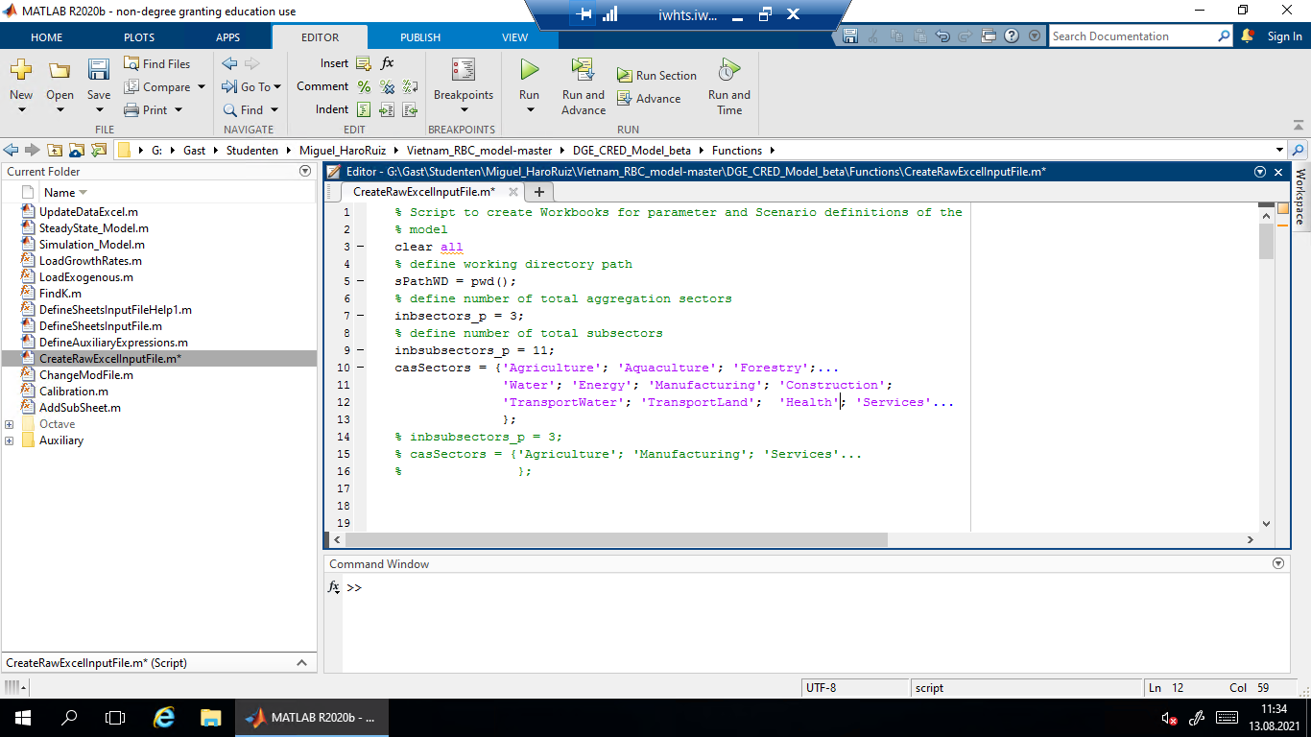

1. The number of sectors can be **(1)** set by using the variable *'inbsectors_p'*. For instance, to create a excel sheet with three sectors, set line 7 of the *.m* file to *'inbsectors_p = 3;.'* Furthermore, the subsectors' characteristics are controlled by two variables.

**(2)** *'inbsubsectors_p'* determines the number of subsectors, and must be at least equal to the number of sectors defined with *'inbsectors_p.'* Following the example with three sectors, to create a excel sheet with three subsectors (one in each sector), set line 9 of the *.m* file to *'inbsubsectors_p = 3.'*

**(3)** *'casSectors = { }'* defines the specific subsectors by assigning names to each of them. Thus, the number of strings included in this variable must be equal to the number set for *'inbsubsectors_p.'* Continuing the example, to create an excel sheet with 3 sectors and 3 subsectors, include three subsector names in quotation marks, separated by commas inside the curly brackets.



1

2

3

1. **(1)** The number of regions is defined using the variable' *inbregions_p.'* For instance, to create an excel sheet with 3 regions, set the line 27 of the *.m* file to'*inbregions_p= 3;.'*

Furthermore, **(2)** *'casRegions = { }'* allows the user to name each of the regions defined with '*inbregions_p.'* Following the example with three regions, include three regions names in quotation marks, separated by commas inside the curly brackets.

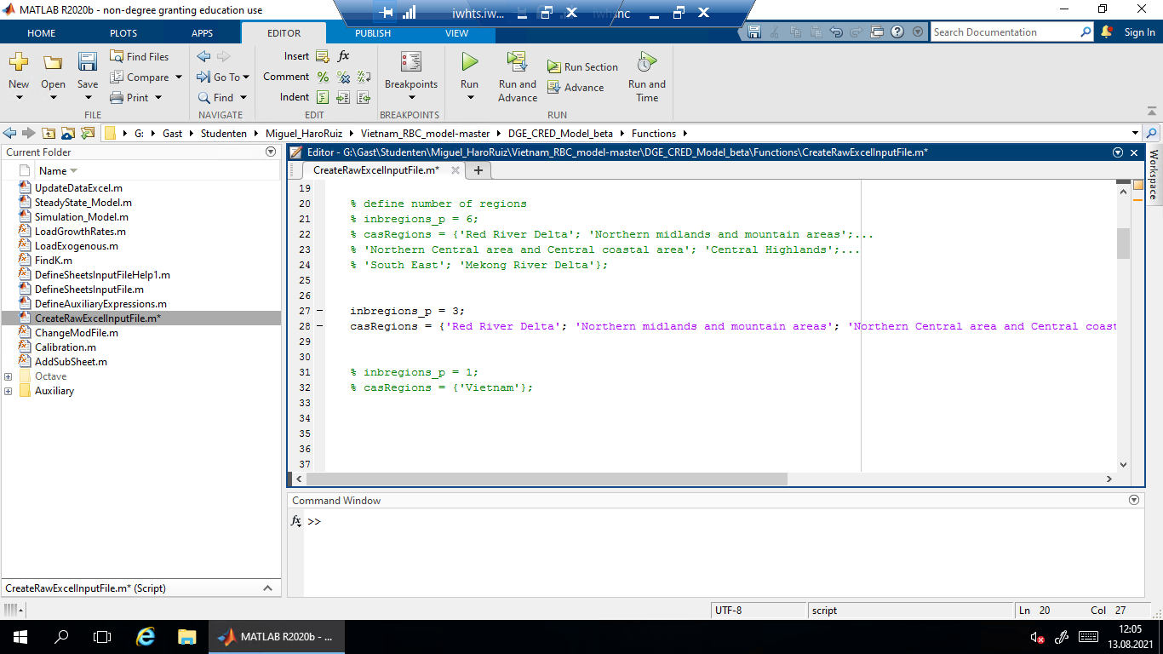

1

2

1. A final set of customisable elements the user can define are the national aggregates, as well as the regional and national climate variables. **(1)**To create an excel sheet with different national aggregates, use *'casNationalAggregates = { }* and include them in quotation marks, separated by commas inside of the curly brackets.

**(2)** Regional climate variables are controlled by *‘casClimateVarsRegionalName = { }’* which defines the name of each climate variable, and casClimateVarsRegional = { }, which specifies the variable name for each climate variable. Make sure both variables have the same number of elements. **(3)** National climate variables are defined analogously, using the *‘casClimateVarsNationalName = { }’* and *‘casClimateVarsRegional = { }.’*

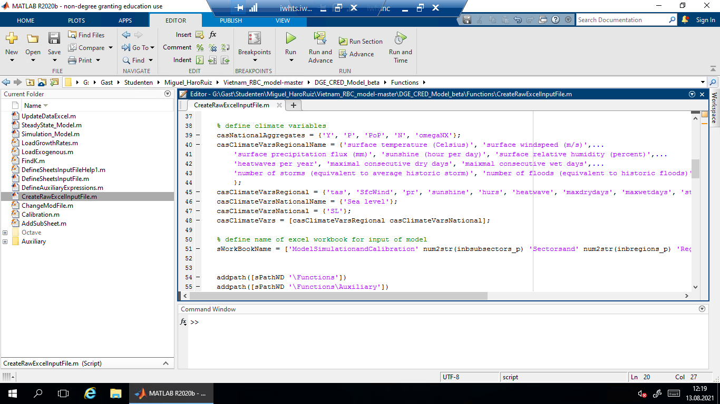

3

1

2

1. Once you have made the necessary changes to the *CreateRawExcelImput.m* fileand made sure that none of the variables is defined more than once, **(1)** save it by clicking on the 'Save’ icon in the menu bar. Next, **(2)** go back to the ‘DGE_CRED_model’ folder in the file browser and **(3)** click on the ‘Run’ icon in the menu bar. A message window will appear; select ‘add path’ to execute the program.

An excel sheet named ***ModelSImulationandCalibrationKSectorsandRRegions.xlsx***, where K and R are the number of defined subsectors and regions, respectively, will be saved in the *ExcelFiles* folder.

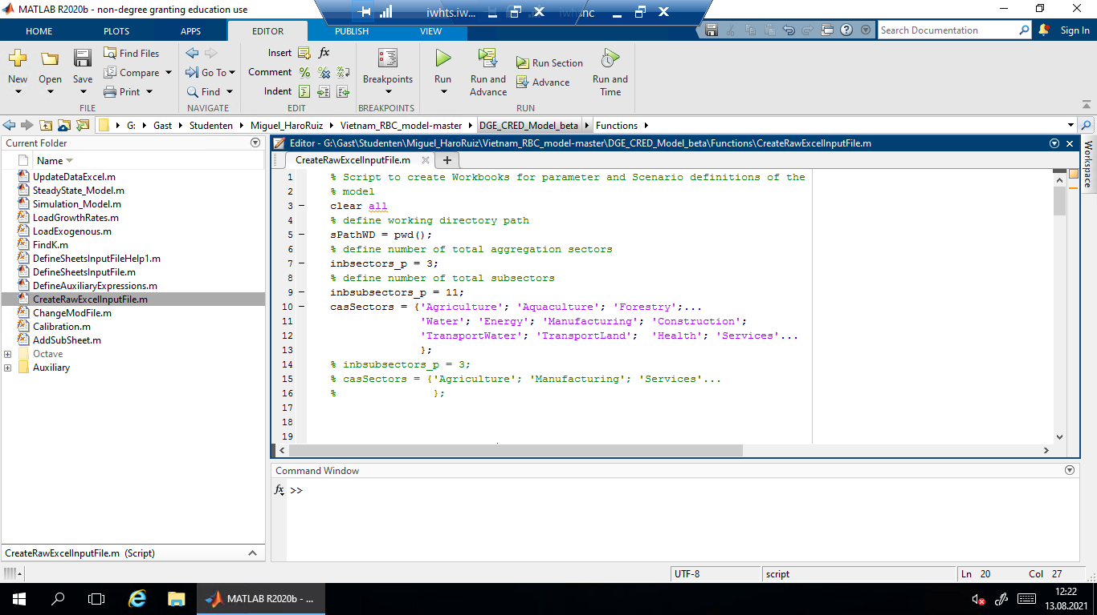

1

3

2

# Sectoral damages and adaptation measures

This section describes the calibration process of the Model so that it reflects the way in which the Vietnamese economy responds to climate change-related events. Furthermore, the climate scenarios used in the Model are explained. The following sections are dedicated to four sectors of the Vietnamese economy: agriculture, forestry, housing and transport. Each of the sections reports how climate variables affect the sector under consideration, as well as how adaptation measures can reduce climate-induced damages.

For a complete description of the calibration process, as well the mechanics of climate scenarios with respect to each sector, please refer to Section 3. Scenario Analysis of the Model Description.

## Calibration

In order to examine how different climate change variables affect the production process in Vietnam, it is necessary to calibrate the Model such that it reflects the current situation of the Vietnamese economy. We do so with data for the year 2014 since it constitutes the last year for which we have observed data.

In terms of production, the Model uses a Cobb-Douglas production function. Therefore, we must calibrate the output elasticities of capital and labor such that they match observed parameters i.e. the share of the wage bill on gross value added for a given elasticity of substitution. Furthermore, we specify how labor supply responds to wage changes, as well as the rate of capital stock depreciation, which is assumed to be equal across sectors and regions. Taxation in the Model is simplified, such that all tax revenues of the government come from a tax on consumption, which is set to 20%. This rate reflects the relation between total tax income and consumption in Vietnam in 2014.

The initial population used by the Model reflects the population in Vietnam in the baseline year, as reported by the country’s General Statistical Office, which is about 90.7 million people. The initial GDP is equal to 186 billion dollars as reported by the world bank. The Model also requires the initial share of hours worked, which we obtain from the average weekly hours worked, as well as the share of employed individuals. Furthermore, the share of investment into housing with respect to GDP is defined.

## Climate Scenarios

For a detailed description of how to simulate different scenarios, see Section 4.3.

A variety climate scenarios can be implemented through the ***DGE_CRED_Model.mod*** file, using abbreviations for climate variables. New climate variables can be added to the mod-file depending on whether data is available at the regional or national level.

The simulation of different climate scenarios can be adjusted using the RunSimulations.m file. In addition to the baseline scenario, which only considers population growth, new climate pathways can be included using the commands “SSP126” and “SSP585”. Figure 1 illustrates the main steps in developing the SSPs, including the narratives, socioeconomic scenario drivers (basic SSP elements), and SSP baseline and mitigation scenarios.

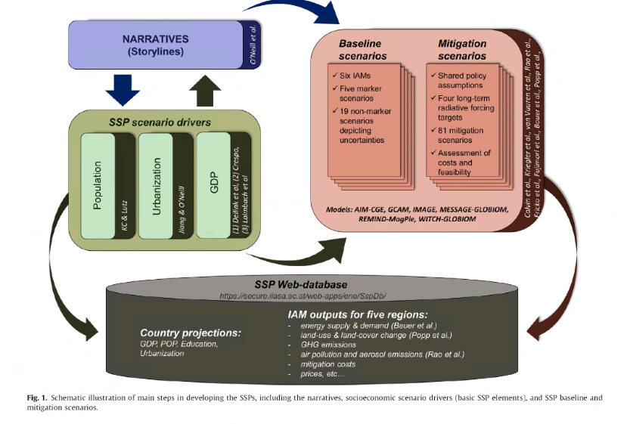The data for the different climate pathways is obtained from the Excel sheets named “SSP126” and “SSP585”, included in the ***ModelSImulationandCalibrationKSectorsandRRegions.xlsx*** file.

Figure 1. Schematic illustration of steps to develop SSPs scenarios.

## Agriculture Sector

Damages to the agricultural sector are implemented in the Model as a result of changes in temperature as well as changes in sea level rise. Firstly, a reduction of crop yields due to an increase in temperature will reduce the maximum number of crops produced in a given period using the same amount of production factors. Secondly, land loss due to sea-level rise will force farmers to produce with less land. This implies that the same number of workers and the same capital stock can only be used in smaller area. The impact of sea-level rise and temperature increase affects total factor productivity through D1 and D2.

For example, we specify the damages D1 in the rice sector, based on the damage that resulted from an increase in atmospheric temperature and sea level. An increase in temperature by 1°C, the damage will increase by 3.1%. For sea level a step-function relationship is expected according to the land loss bins.

soybean

maize

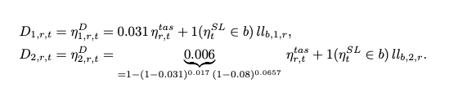

share in gross value added

For D2, i.e the damage in agriculture excluding rice, we can directly use the values from the literature (see Table 1) and multiply them by the share of value added to agricultural 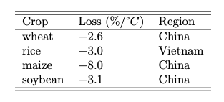sector as given in the input-output table (See Model Description for details). For instance, the share of soybean is 1.7% and maise 6.6%.

Table 1. Crop yield loss

Source: Zhao et al. (2017).

Adaptation in the agricultural sector occurs in different ways. For instance, by switching production from the more affected sectors to the less affected sectors or regions in Vietnam. This is possible by assuming that agents adapt from highly vulnerable to less vulnerable sectors through optimal behavior. Additionally, the loss in total factor productivity can be compensated by investing more into the capital stock.

## Forestry sector

Damages to the forestry sector in Vietnam are included in the Model through the hazard of forest fires. The frequency of forest fires is computed using the so-called Keetch-Byram Drought Index (KBDI), which is used to predict the risk of forest fires depending on the daily maximum temperature, as well as daily and annual average rainfall.

Using historical data on burned area in Vietnam, we determine that a KBDI value larger than 150 indicates good conditions for a forest fire to develop. In this sense, a fire occurs in a given region with a probability of 42% if the cumulative KBDI for a week exceeds 150, and only with a probability of 15% if the KBDI is below the threshold. The damage due to forest fire in the forestry sector for each region is computed by multiplying the number of forest fires in the region for the respective year with the fraction of land burned from the historical database.

The adaptation measure in the forestry sector consists of changing one hectare of pure eucalyptus forests to mixed forests with eucalyptus and pine. After the adaptation measures have been implemented, the burned area per fire in the region is reduced. However, the adaptation measures only reduce the burned area after completion of the adaptation measure, which is assumed to be 10 years. Table 2 shows the damage caused by forest fires with and without adaptation measures.

## Housing sector

Damages in the housing sector are implemented in the Model as a result of storms as well as changes in the sea level. On the one hand, the frequency of storms is different across regions for which the Model simulates the storm occurrences through an exogenous variable. Furthermore, it is assumed that storms will destroy 10% of the houses in a region, for which the regional damage depends on the number of houses in each region. In terms of sea level, it is assumed to only affect housing in coastal regions and that 10% of the houses affected by floods in a region will be destroyed. The share of construction land loss for a specific range of sea-level rise is used to estimate the costs to the housing stock.

The Model includes two adaptation measures for housing. Firstly, it is possible to build houses with reinforced walls and bricks to reduce the vulnerability of houses to storms. Additionally, raising a house on stilts will reduce the impact of an increase in sea-level. The damages caused by sea-level rise and storms are subtracted from the benefits associated with the necessary cumulative costs for the adaptation measures.

## Transport sector

Damages to the road stock in Vietnam are incorporated into the Model through damages to the capital stock of the land sub-sector. There are three ways in which roads can be damaged. First, a rise in sea level can flood some of the roads. Second, consecutive days with temperatures above 30°C can destroy the asphalt. Finally, landslides constitute another factor which can destroy transport-related infrastructure. Roads are classified by type (highways, national and provincial roads), as well as their vulnerability to climate events (very low, low, medium, high, very high). For the model simulation, damages and costs across road types and vulnerability levels are aggregated such that subjective probabilities are assigned to different vulnerability classes in order to compute expected damages on the road stock.

Three adaptation measures are considered. First, elevating affected roadbeds by a certain amount can tackle rises in sea level. If this is done before the sea level rises, the potential damage will be reduced to zero. Second, replacing conventional asphalt concrete with polymer asphalt concrete can protect the road from high temperatures. It is assumed that as soon as soon as the implementation of this measure has begun, the damage posed by heatwaves is zero. Third, measures against road erosion are used to mitigate the impact of landslides on the road stock and take only a year to be implemented.

# Practical session

## Practical Session 1

**Task 1**: Create an Excel input file with 12 subsectors and 1 region.

* Use the ***CreateRawExcelInputFile.m*** file, located in the Functions/Miscellaneous folder. You need to run it in the main directory of the model *‘.../DGE_CRED_Model/*’ and select “add path”, as opposed to “change path.”
* *Subsector names:* Rice, Agriculture excluding rice, Aquaculture, Forestry, Water, Energy, Manufacturing, Construction, TransportWater, TransportLand, Health, Services.
* *Region name:* Vietnam.
* *regional climate variables names:* surface temperature (Celsius), surface windspeed (m/s), surface precipitation flux (mm), sunshine (hour per day), surface relative humidity (percent), heatwaves per year, maximal consecutive dry days, maximal consecutive wet days, number of storms (equivalent to average historic storm), number of floods (equivalent to historic floods), number of forest fires, landslides.
* *regional climate variables symbols*: tas, SfcWind, pr, sunshine, hurs, heatwave, maxdrydays, maxwetdays, storms, floods, fires, landslides.
* *national climate variables names:* sea level (cm).
* *national climate variables symbols:* SL.

**Solution to task 1**:

1. Initiate *MATLAB* and open the ***CreateRawExcelImputFile.m***, located under *Functions/Miscellaneous*. Make sure that the optimisation toolbox is installed in MATLAB.
2. 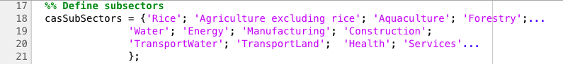We will include 12 subsectors, for which the variable “*casSectors*” must include each of the 12 subsectors’ names within curly brackets ( {…} ). Be sure to type each subsector name within quotation marks (‘…’) and separated by commas, as shown below.
3. The task prompts us to work with a single region, which we will call Vietnam. As a result, the variable “*casRegions*” must be set equal to “Vietnam”, in quotation marks and within curly brackets, as follows.
4. 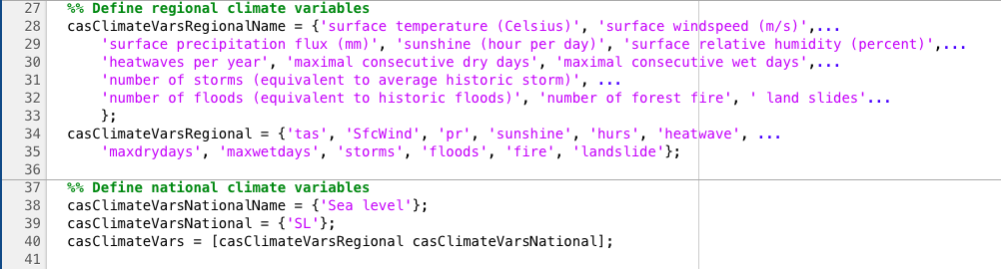Next, define the regional climate variable names under the variable “*casClimateVarsRegionalName*”, as well as the climate variable symbols under the variable “*casClimateVarsRegiona.l*” Make sure to type every name and symbol within quotation marks, separated by commas and in between curly brackets. Similarly, define national climate variable names and symbols within “*CasClimateVarsNationalName*” and “*CasClimateVarsNational*”, respectively. Your input should look like the one below.

**IMPORTANT**: Before executing the file, make sure that none of the previously defined variables are included twice. In order to avoid defining variables twice, you can write “%” in front of the lines with extra definitions or delete these lines altogether.

1. Now that all the relevant variables are defined, navigate back in the file browser such that the current directory is the main DBE_CRED_Model file. Run the ***CeateRawExcelImputFile.m***. A window will pop up informing the user that the file to be executed is not included in the current directory; select “add path” and wait for the program to finish executing.
2. To see the output of the program, go to the “ExcelFiles” folder and select the newly created ***ModelSimulationandCalibration12Sectorsand1Regions.xlsx*** file. Notice that while the raw outline of the Excel file that feeds the Model has been created, the data needs to be imputed by the user.

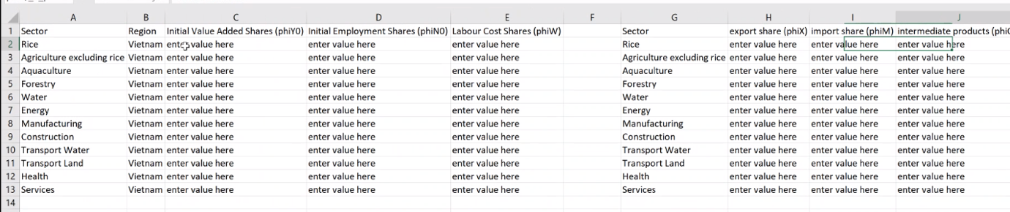The “Data” sheet looks as follows.

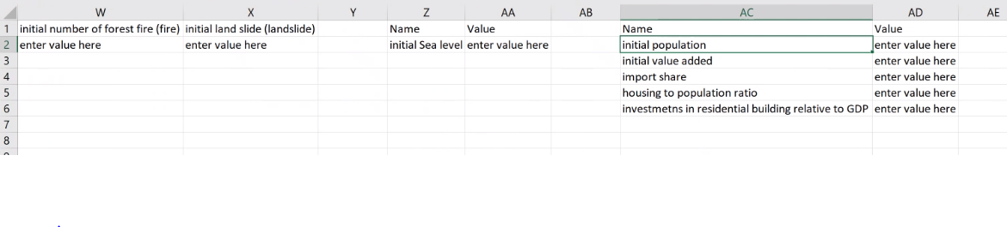The “Start” sheet looks as follows.

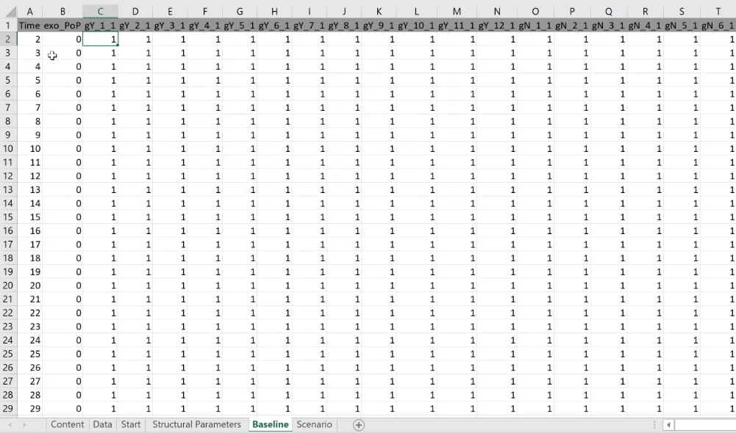The “Baseline” sheet looks as follows.

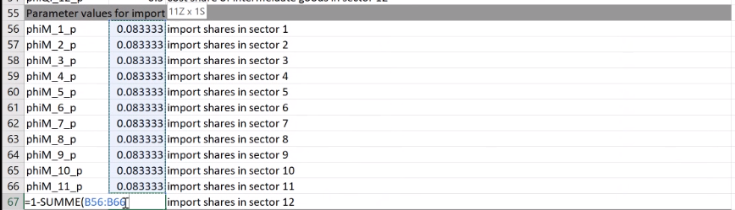**NOTE**: In the “Start” and “Structural Parameters” sheets, the shares should add up to 1. In order to test this, type “1-SUM(share sector 1; share sector 2;…; share sector 12)” in an empty cell, as shown in the picture below. If the result is no equal to 0, a message will occur when you simulate the Model in MATLAB.

**Task 2**: Run the ***RunSimulation.m*** file.

* Test whether the created input file is a valid input to conduct simulations.
  + Run the model simulation in the baseline scenario.
  + Execute the program with 12 subsectors and 1 region.

**Solution to task 2:**

1. Initiate *MATLAB* and open the ***RunSimulations.m***, located in the main *DGE_CRED_Model* file. Since we want to simulate the baseline scenario, the variable “*casScenatioNames*” should be set equal to “Baseline”, in quotation marks and within curly brackets, as follows.
2. 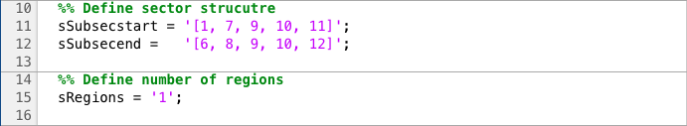Next, define the distribution of subsectors using the variables “sSubsecstart” and “sSubsecend.” For a more detailed description of how to do this, refer to Section 4.3 of the manual. Furthermore, the number of regions should be set to 1 through the variable “sRegions.” Your input should roughly look like the one below.
3. Finally, click on the “Run” icon. Throughout a successful execution of the simulation, your output should be the following.

**Task 3**: Calibrate the Model.

* Fill the Excel file ***ModelSimulationandCalibration12Sectorsand1Regions.xlsx*** with the following data on
  + Subsectoral exports, imports, and intermediate products

|  |  |  |  |
| --- | --- | --- | --- |
| Sector | Export Share | Import Share | Intermediate Products |
| Rice | 0,0121 | 0,0003 | 0,5592 |
| Agriculture excluding rice | 0,1410 | 0,0407 | 0,6669 |
| Aquaculture | 0,7670 | 0,0002 | 0,7111 |
| Forestry | 0,3750 | 0,0446 | 0,5527 |
| Water | 0,0010 | 0,0001 | 0,6108 |
| Energy | 0,0082 | 0,0202 | 0,5776 |
| Manufacturing | 0,3368 | 0,8331 | 0,8198 |
| Construction | 0,0010 | 0,0001 | 0,7585 |
| Transport Water | 0,1872 | 0,0001 | 0,7508 |
| Transport Land | 0,1081 | 0,0049 | 0,5507 |
| Health | 0,0116 | 0,0030 | 0,5953 |
| Services | 0,1226 | 0,0526 | 0,5637 |

* + Subsectoral value added, employment and labour cost

|  |  |  |  |
| --- | --- | --- | --- |
| Sector | VA Shares | Employment Shares | LC Shares |
| Rice | 0,031810 | 0,100255 | 0,494986 |
| Agriculture excluding rice | 0,072820 | 0,229508 | 0,501080 |
| Aquaculture | 0,026922 | 0,084851 | 0,526193 |
| Forestry | 0,014400 | 0,045386 | 0,583953 |
| Water | 0,006530 | 0,002700 | 0,199205 |
| Energy | 0,079610 | 0,002600 | 0,234692 |
| Manufacturing | 0,292172 | 0,140000 | 0,481682 |
| Construction | 0,044659 | 0,062000 | 0,724319 |
| Transport Water | 0,008473 | 0,002291 | 0,564652 |
| Transport Land | 0,098791 | 0,026709 | 0,585345 |
| Health | 0,013103 | 0,009300 | 0,691108 |
| Services | 0,310710 | 0,294400 | 0,550248 |

* + Climate variables

|  |  |
| --- | --- |
| Climate Variable | Value |
| Initial surface temperature, Celsius (tas) | 22.4754892 |
| Initial surface windspeed, m/s (SfcWind) | 2.71182685 |
| Initial surface precipitation flux, mm (pr) | 2036.516996 |
| Initial sunshine, hours per day (sunshine) | 4.985255811 |
| Initial surface relative humidity, % (hurs) | 85.95630137 |
| Initial heatwaves per year (heatwave) | 0.009803922 |
| Initial maximal consecutive dry days, (maxdrydays) | 21.20634921 |
| Initial maximal consecutive wet days, (maxwetdays) | 30.38095238 |
| Initial number of storms (equivalent to avg. historic storm) (storms) | 0 |
| Initial number of floods (equivalent to historic floods) (floods) | 0 |
| Initial number of forest fire (fire) | 0 |
| Initial landslides (landslide) | 0 |

* + Initial values

|  |  |
| --- | --- |
| Variable | Value |
| Initial population | 0.907280 |
| Initial value added/GDP | 1.86 |
| Import share | 0.223 |
| Initial housing area | 23 |
| Initial employment level | 0.15 |
| Initial investment into housing | 0.005 |

* Once the values have been added to the Excel file, use the program ***UpdateDataExcel.m*** to fill for structural parameters and baseline scenario values.

**Solution to task 3**

* + - 1. Open the ***ModelSimulationandCalibration12Sectorsand1Regions.xlsx*** file, located in the *ExcelFiles* folder. Copy each of columns in the tables above and paste them in the appropriate Excel columns in the “Data” sheet.
      2. Now go to the “Start” sheet and introduce the initial values for GDP, price level, population, employment level and investments into housing. Furthermore, add the initial climate parameter values, as well as initial VA and employment shares for each sector.

**NOTE:** If you want to add additional parameters defined for the Model, or copy them to other positions in the file, make sure that cells are appropriately names. For example, the variable “initial employment level” is defined in the cell C5 of the sheet “Start.” However, we can move it to the empty cell AD7. In order to do this properly, make sure to type the name of the variable in the cell AC7. Additionally, include the variable abbreviation, in this case N0_p, in the upper left field. This is shown in the picture bellow.

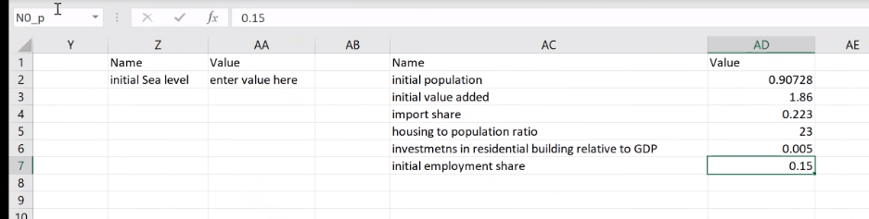

* + - 1. Once all the data has been inserted into the “Data” and “Start” sheets of the Excel file, run the ***UpdateDataExcel.m***. This program will fill the “Structural Parameters” and “Baseline” sheets automatically. However, the “Baseline” values are the same for years 1 through 100. We will deal with this issue in the following task.

**Task 4**: Define the Baseline scenario

* Define the subsectoral value added and employment growth rates, as well as population proyections
* Use data located in the ***BaselineProjections.xlsx*** file, under the ExcelFiles/Data directory.

**Solution to task 4**

Copy the values for each sector and parameter from the **BaselineProjections.xlsx** into the appropriate columns of the “Baseline” sheet of the **ModelSimulationandCalibration12Sectorsand1Regions.xlsx**. The mapping of the variables is the following.

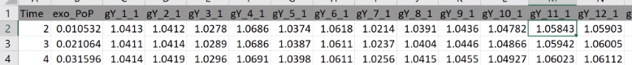

|  |  |  |  |  |  |  |  |  |  |  |  |  |  |
| --- | --- | --- | --- | --- | --- | --- | --- | --- | --- | --- | --- | --- | --- |
| Time | population | Rice | Agriculture excluding rice | Aquaculture | Forestry | Water | Energy | Manufacturing | Construction | TransportWater | TransportLand | Health | Services |

**Task 5**: Plot the Value Added for all sectors

* Use the ***BaselineKeyindicators.xlsx***Excel file in the E*xcelFiles/Figures* directory

**Solution to task 5:**

* + - 1. Execute the RunSimulations.m file on MATLAB and wait until the simulation has concluded.
      2. Open the BaselineKeyIndicators.xlsx file. Define cell A1 as “Baseline” and cell A3 as “ResultsScenarios12Sectorsand1Regions.” The figure should update and show that the growth rate in all sectors remains almost the same as in 2014.

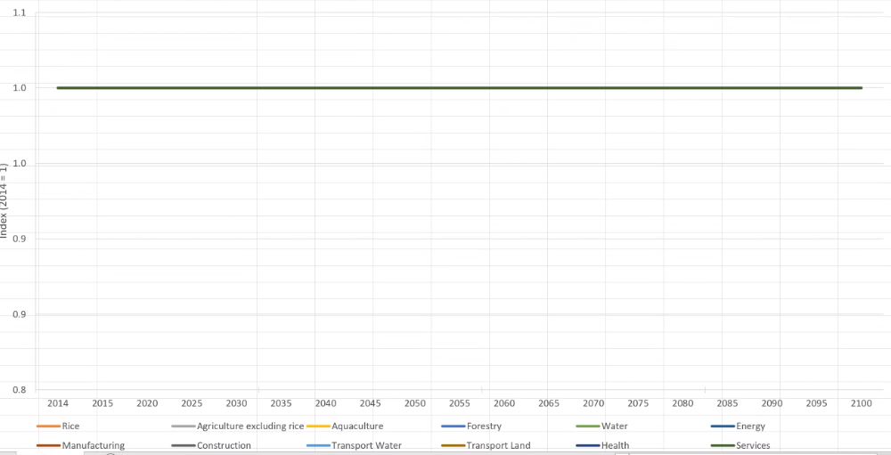

If errors occurs, such as:

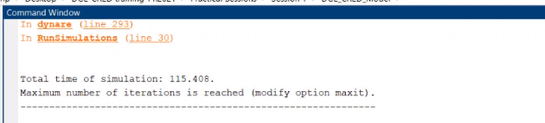

Try to type in the command window

* CTRL+c 🡪 that will stop the program
* type sScenario 🡪 provides feedback whether the scenario is available

In sheet “Scenario” also add the population growth in column B (same as in baseline)

## Practical Session 2

Task 1: Create the SSP 126 and SSP 585 Scenarios

* Create the two scenarios in the ModelSimulationandCalibration12Sectorsand1Regions.xlsx file
* You can use the Scenario sheet as template
* Copy the climate variables from the Excel file ClimateChangeScenarios.xlsx in the ExcelFiles/Data folder

Solution: Copy the scenario sheet and rename it to “SSP126”. Then copy the data from the *ClimateChangeScenarios.xlsx*. The relevant data is saved in the sheets “SSP126”. Repeat the same step for “SSP585”.



Task 2: Run the SSP scenarios and plot GDP

* Modify the RunSimulation.m file
* Use the KeyIndicators.xlsx in the ExcelFiles/Figures folder to plot GDP
* What do you observe and why?

Change the names of the scenarios to run respectively.

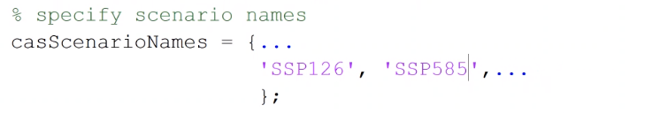

If an error message occurs, make sure that you have the right version of Dynare selected.

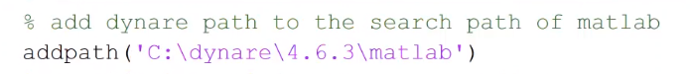

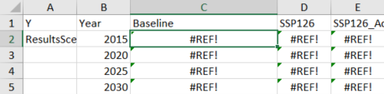In the *KeyIndicators.xlsx* *RiceandAgriculture.xlsx*, in sheet “y” the references are missing,

Change the name in A1 to “Y”.

As an example, *ModelSimulationandCalibration.xlsx* in the column B shows the difference from population growth rates compared to the t0 period is shown. If you want to calculate the level for each period (see column AC).

Data by GSO is only provided until t36 (therefore it remains the same until the end of the simulation).

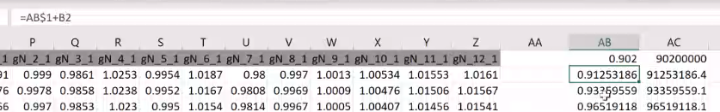

exo_PoP .. difference from population growth rates compared to the t0 period

gY.. growth rate gross value added

gY_1 subsector 1

gy_1_1 region1

gN .. growth rate for employment shares

gN_1 subsector 1

gN_1_1 region1

gY_1_1 is 1.041 this implies a growth rate 4.1%

After Matlab results are saved the we see that GDP is the same for different scenarios ~~across all regions.~~

Because we did not define any damages yet.

*In Riceand Agribulture.xlsx:* All values are provided in levels (but in line with the underlying growth rate in *ModelSimulationandCalibration.xlsx*). If you want to see the results for other parameter, e.g. for consumption, copy a sheet and rename “c”, enter in A1 the variable of interest.

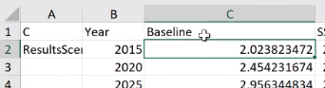

Task 3: Define damages on the rice and agriculture sector excluding rice

* We assume that with a one degree increase in annual temperature rice crop yields decline by 3 %/°C
* For the agriculture sector excluding rice we assume that crop yields decline by 0.6 %/°C.

In *ModelSimulationandCalibration.xlsx*  select in sheet “SSP126”, the relevant variable is named exo_D_1_1 (column AB), that’s the damage in agriculture sector excluding rice. We link the damages provided in sheet *Damage.xlsx* to the associated temperature increase

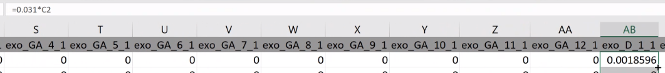

(WIR WAR ICH LEIDER abwesend)

Task 4: Include damages induced by sea level rise

* Use the excel file Damages.xlsx to incorporate the loss in land by sea level rise.
* Therefore, use the function VLOOKUP and assume that a percentage change in agricultural land leads to the same percentage change in TFP. It means that damages are a one to one mapping of the land lost by sea-level rise.
* Run the simulation and analyse the plots.

In the file *Damage.xlsx,* the land loss for up to 5cm increase (1st bin, row 3) in Seas level in Red River Delta is 0.1858 km but no effect in Northern …

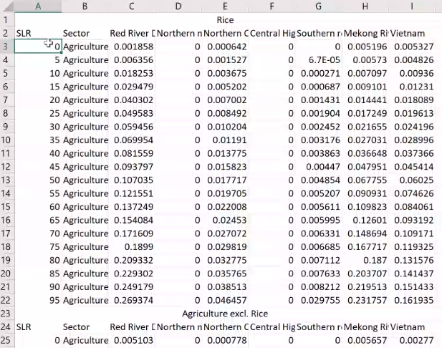

bins

*ModelSimulationandCalibration.xlsx*  select in sheet “SSP126”, the relevant variable is named exo_D_1_1 (column AB),

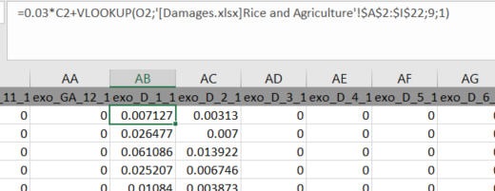

For exo_D_2_1 we link the damages as before:

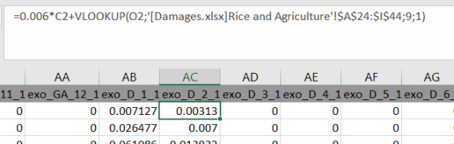

* Open *RiceandAgriculture.xlsx* in the ExcelFiles/Figures folder.
* Open the file with the name *ResultsScenarios12Sectorsand 1Region.xlsx* then the results are provided (and not #ref errors) and also figures are updated.

Explanation:

The impact on gross value added in the sector increases even more. Gross value added declines by more than the direct damage. Damages in the agriculture excluding rice sector due to an increase in temperature.

However, the result that damages trigger an overproportional decline in the affected sector holds.

Consumption and GDP decline and investment increases.

A decline of productivity by 9% in22% until 2100,

…

## Practical Session 3

Task 1: Define damages for the forestry sector

* We will now also consider the potential of adaptation measures.
* We assume that per fire about 0.000926% of the forest area in Vietnam is burned.
* If all adaptation measures are implemented the burned area per fire declines to 0.000592% of the forest area.
* Please implement this into the Model.

Forestry is the 4th sector in the Model.

Exo_D_4_1 … damage induced by climate change, i.e. damage multiplied with number of fires in column M

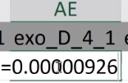 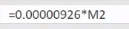

Exo_GA_4_1

In Damages.xlsx sheet “Forestry”

Column P and following Damage/GDP (relative cost to GDP 2014) for all regions. Total refers to Vietnam

If we assume that there is no recovery this scenario is unrealistic. Therefore, we only a fraction of the burned area can be burned again (1- 1/x). For instance x=80, i.e. it takes 80 years that a burned area is recovered again. The larger the number, the closer we get to no recovery scenario. If x=1, than the no recovery at all.

Function depending on particular threshold:

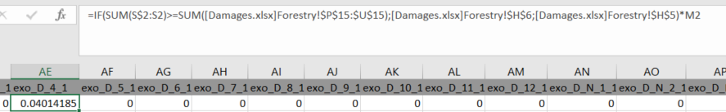

 Reduce simulation speed:

Open DGE_CRED_Model.m

Reduce the simulation steps to 5 instead of 20 to reduce the simulation

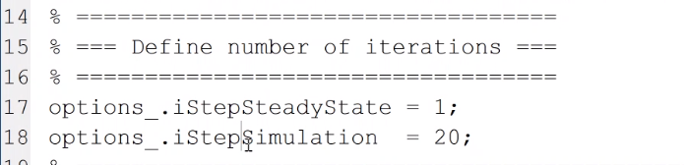

Planted forests burn more than natural forest.

In Results .xls, sheet “SSP126” see variable D_4_1

Task 2: Define adaptation scenarios for the forestry sector

* Define adaptation scenarios for the forestry sector: SSP126AdaptForestry and SSP585AdaptForestry
* Use the Damages.xlsx file to include the adaptation costs.

Solution:

Define adaptation scenarios for the forestry sector: copy SSP126 and SSP585 (as template) and rename it to SSP126AdaptForestry and SSP585AdaptForestry

Exo_GA_4_1… government expenditure

Copy the adaptation expenditures, Total cost (column V), for the sector from the Damages.xlsx file to the Model simulation.xls (Note, copy only values not formulas!)

We have only 10 year adaptation costs, after that the forecasts might be recultivated. And furthermore, sectoral experts provided only expenditures up to 10 years.

In which year we expect the first difference between SSP126 and SSP126 forestry adaptation?

In SSP126 we set up only damages for forestry damage. In adaptation measures are implemented

Differences occur after 10 years (cell AE11), SSP126 forestry is smaller than SSP126. Why after 10 years? As we implemented in step function in the expenditure.

Again specify scenario names

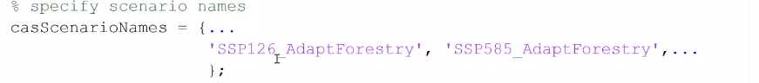

Task 3: Define damages to the capital stock of the forestry sector

instead of damages to TFP

* Create a new workbook called
* ModelSimulationandCalibration12Sectorsand6Regions_D_K_4.xlsx
* In RunSimulation.m define sSensitivity to _D_K_4
* Now you need to run all scenarios again.

We aim to switch the impact channel form TFP to capital stock.

Create new sheets in *ModelSimulationCalibration.xlsx* to “SSP126” to “SSP126_D_K_4”

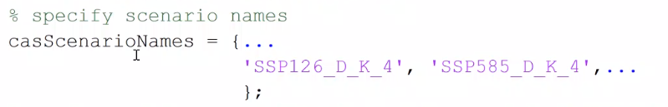

Now one can use the Forestry.xlsx to compare the simulation results for the two versions of implementing the damages.

Therefore, one can create copies of the existing sheets and replace the ResultsScenarios12Sectorsand1Regions.xlsx with

ResultsScenarios12Sectorsand1Regions_D_K_4.xlsx

Task 4: Assume a doubling of annual fires in the SSP 585 scenario

* Create a new scenario SSP585_highfire with twice as many fires per year as in the SSP585.
* Evaluate the impact on consumption, GDP and investment.
* Do we have a linear or non-linear relationship between percentage consumption loss and the annual number of fires?.

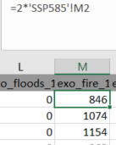Again, create (i.e. copy) the sheet for “SSP585_highfire”, change the formula to 2*SSP585 column M.

Check whether values for damages are plausible (D highfire >D SSP585)

Change the simulation names in m-file

In Folder Figures copy *RiceandAgriculture.xlsx* and rename it *Forestry.xlsx* and open *ResultsScenario.xlsx* to see the numbers.

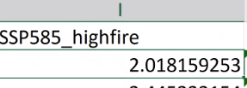Insert a new column and name the scenario

At the end of the simulation period one can compare the results:

For consumption, the loss in consumption in SSP585 is about -2.5% compared to the baseline, and - 3.8% for highfire.

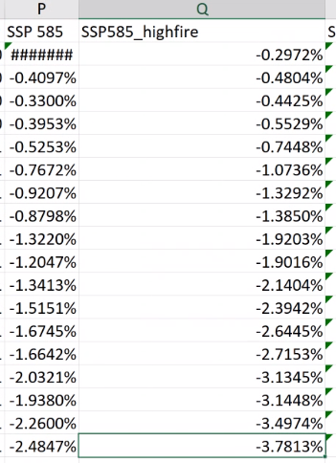

GVA Investment

 

 What if we want consider more regions?

Create new Excel-file (or take the templates), e.g. 12 sectors, 6 regions, than the relevant columns include 1-6 regions. All steps have to repeated for each region, starting from adding data for all regions, e.g. temperature..



## Practical session 4

Task 1: Define damages for the housing/construction sector by storms

* Use the Damages.xlsx file to define the damages.
* Assume that in Vietnam storms occur in four out of five years.
* If a storm occurs, it creates a damage to the housing stock of about 0:0045% relative to GDP.

In file Damages.xlsx sheet “transport” all damages are quantified by the sectoral experts. For Vietnam, e.g.:

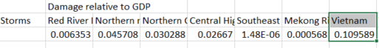

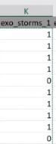Define storms every 4 out of five years in Vietnam.

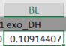

Now add a column (BL) for exo_DH and set the values according to the defined damages (note: as an example this value is different compared to the value provided by sectoral experts). , where column K includes the number of storms exo_storms_1.

Task 2: Define damages for the housing/construction sector by sea-level

* Use the Damages.xlsx file to define the damages.
* Here you need to use the VLOOKUP function to include the damages for different sea-levels.
* Damages/Benefits are reported in A25:H45.

Sea-level (column O), avoided damage (benefit

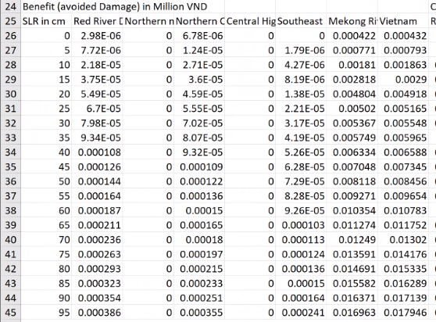



Task 3: Include adaptation measures against storms

* Use the Damages.xlsx file to define the adaptation costs.
* Define the scenarios SSP126_AdaptConstruction and SSP585_AdaptConstruction
* Adaptation costs are reported in Q48:W88.
* How effective is the adaptation measure?

Open *ModelsimulationCalibration.xlsx*

Copy SSP126 and rename SSP126_AdaptConstrucion (same for SSP585)

Add column Exo_G_A_DH … expenditure for housing stock

Now, relate expenditure to damages, i.e. substract the avoided benefits

Copy the SSP585 and SSP126 scenario sheets to create the sheets

SSP126_AdaptConstruction and SSP585_AdaptConstruction

_ One needs to define a column for exo_G_A_DH in the sheets.

_ Use the Damages.xlsx file to define the costs of different adaptation

measures.

_ Subtract the damages and make sure that damages do not get negative.

Task 4: Include adaptation measures against sea-level

* Use the Damages.xlsx file to define the adaptation costs.
* Assume a just-in time implementation with VLOOKUP
* The costs and benefits are reported in A35:O35.
* How effective is the adaptation measure?

We assume a just-in-time policy for exo_G_A_DH in the sheets.

* Use the Damages.xlsx file to define the costs of different adaptation
* measures.
* Damages are set to zero if the costs are implemented.

Add the adaptation costs induced by sea-level to storms adaptation costs.

Multiply the damages induced by sea-level with zero.

Vlookup specific increase in sea level, and associated cost to avoid the damage A25:O45

Multiply with zero … EXPLAIN again?

Task 5: Evaluate the effectiveness of adaptation measures with

* suitable variables Use the Agriculture and Rice.xlsx file to create suitable graphs.
* Damages occur until 2035
* Investments into housing are more than 20% higher compared to the baseline

## Practical session 5

Task 1: xx

*Training Impressions*

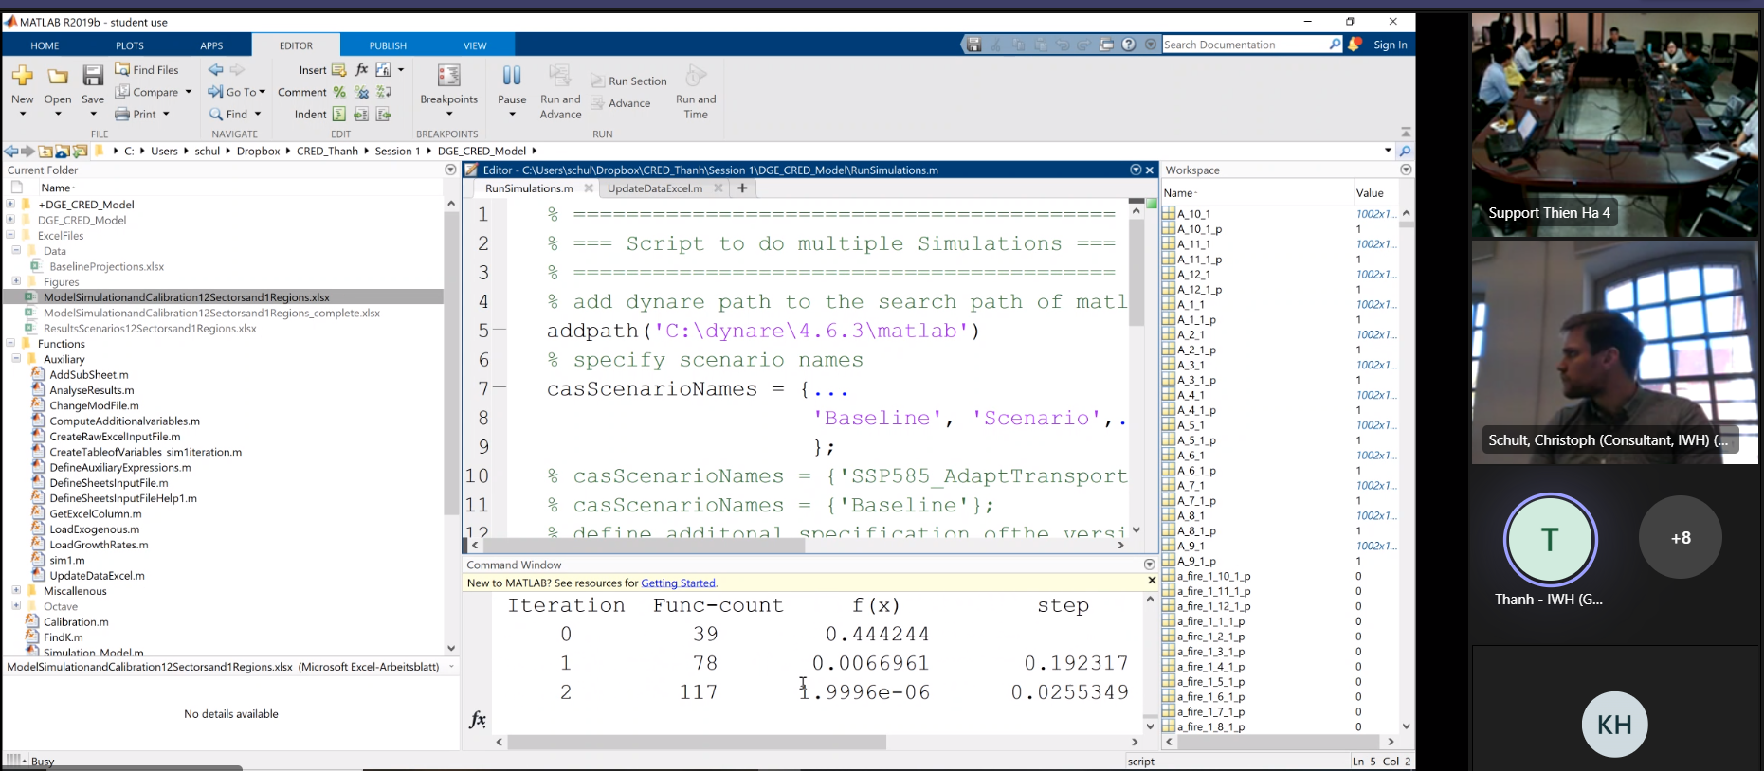

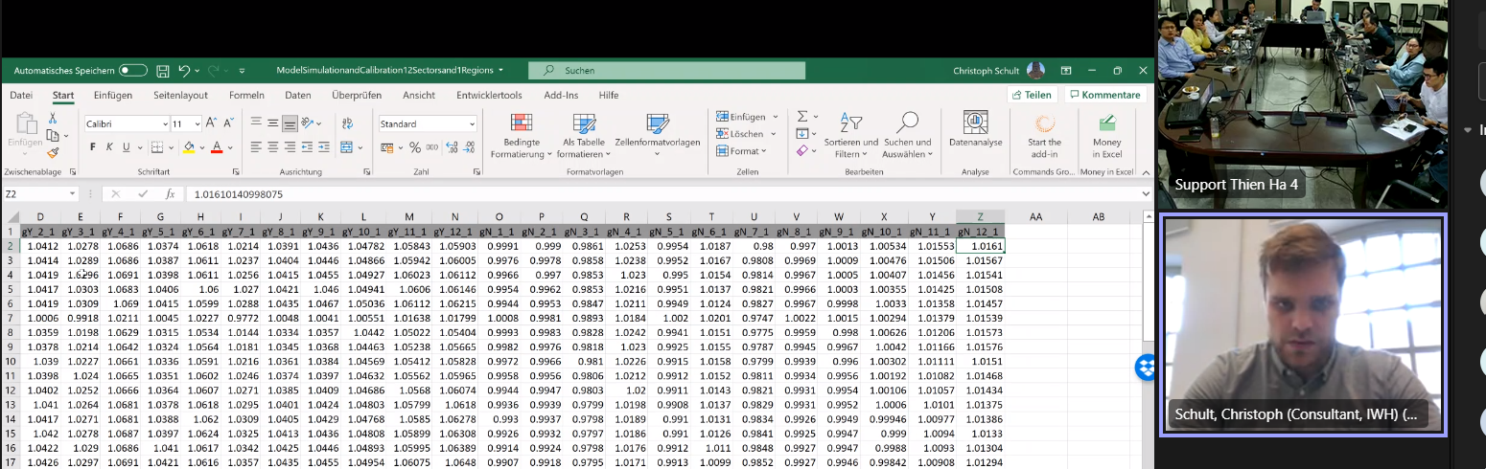

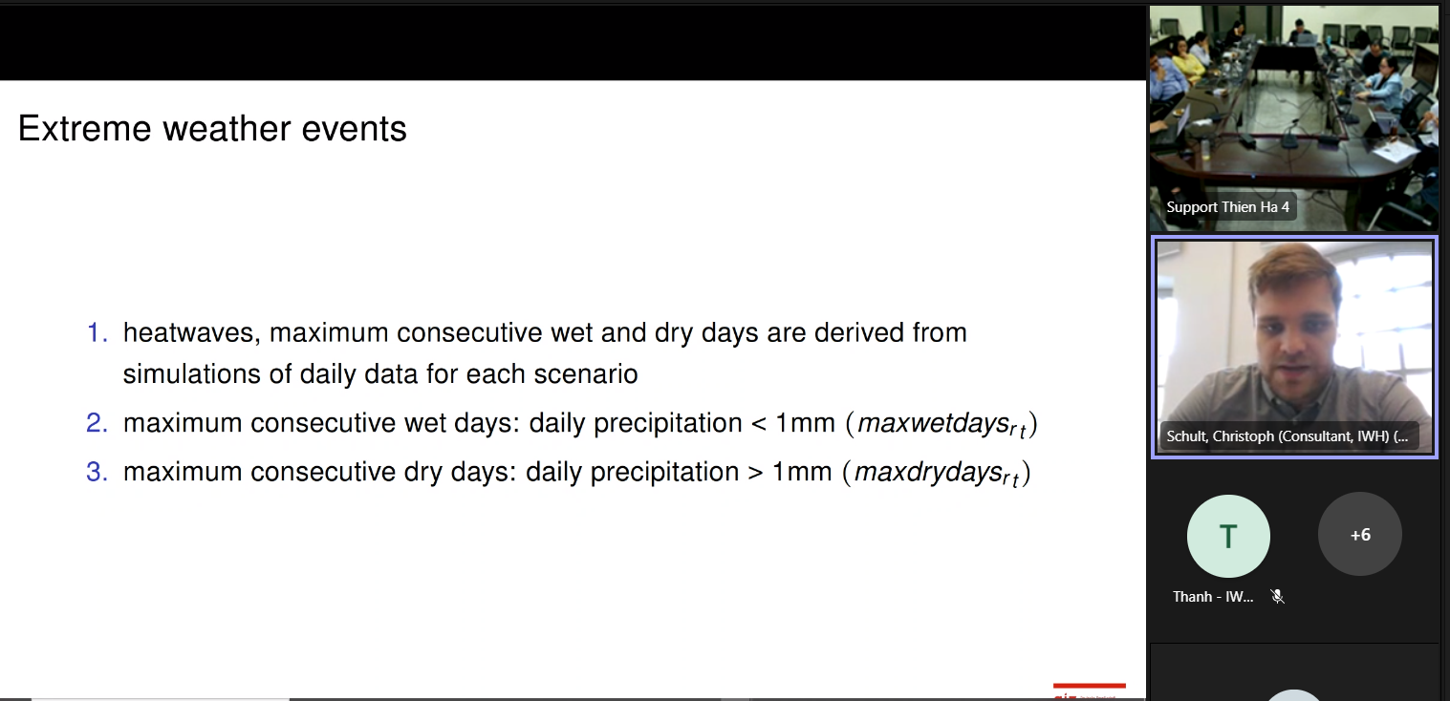

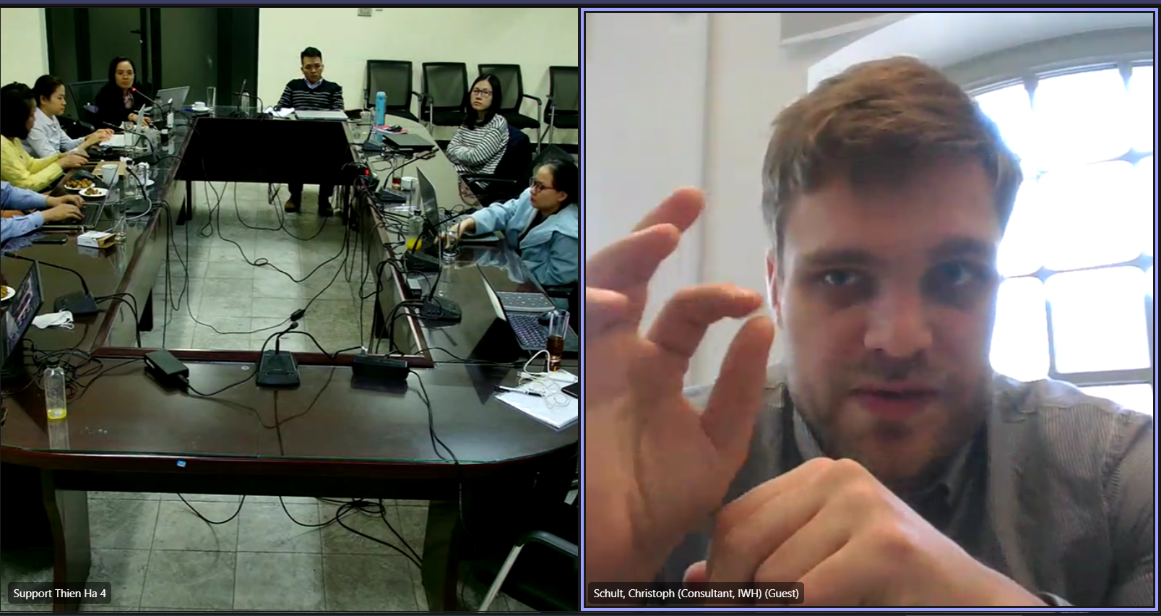

# Appendix

## MATLAB Functions

The different MATLAB functions needed to simulate the Model are described in this section.

LoadExogenous.m

This function is included in the ***DGE_CRED_Model_Simulations.mod*** file, which is executed for each scenario specified in the ***DGE_CRED_Model.mod*** file. The inputs used by this program are the following:

* ﻿sWorkbookNameInput: Variable which contains the excel sheet ***ModelSimulationandCalibrationKSectorsandRRegions.xslx***, where the exogenous variables for each scenario are specified.
* sScenario: Variable containing the specific scenario of the simulation
* oo_: *Dynare* structure containing various simulation results.
* M_: *Dynare* structure containing various information about the Model.

The program reads the 'sScenario' sheet in 'sWorkBookNameInput' and determines which variables of the scenario are included in the model variables vector, 'M.exo_names.' This information is used to add values to the vector 'oo_.exo_simul', which contains the paths for the exogenous variables to be used in the simulation. Thus, the program produces the following output:

* oo_: *Dynare* structure containing various simulation results. More specifically, an updated version of oo_.exo_simul.

Simulation_Model.m

This Matlab script calls the perfect foresight solver of Dynare. It divideds the original perfect foresight problem in small steps to find the solution of the problem. It calls the function *FindK.m*.

SteadyState_Model.m

This Matlab script calls the respective excel input file and calibrates the Model. It calls the *DGE_CRED_Model_steadystate.m* file and the *Calibration.m*.

DGE_CRED_Model_steadystate. m

This function is called by the ***DGE_CRED_Model.mod*** file. The inputs used by this program are the following:

* ys: Vector containing initial values for the steady-state of the endogenous variables.
* Exo: Vector containing initial values for the steady-state of the exogenous variables.
* M_: *Dynare* structure containing various information about the Model.
* options_: Dynare structure containing the values of various options used during the computation.

First, the program retrieves all the model parameters, as well as endogenous and exogenous variables, assigns them a unique name, and stores them into 'M_.params', 'ys' and 'exo', respectively. The next step is determined by the value of the '﻿lCalibration_p' variable, which can be set in the ***DGE_CRED_Model_Simulations.mod*** file.

* If lCalibration_p = 0 or 3, the program uses the function ***FindK.m*** to find vectors with endogenous and exogenous variables that fulfil the static equations of the Model such that the vector with residuals does not contain any elements larger than $1∙{10}^{-8}$.
* If lCalibration_p = 2, the program ﻿calculates sectoral and regional output and labor values. These values are used by the ***FindK.m*** function to find vectors with endogenous and exogenous variables that fulfil the static equations of the Model such that the vector with residuals does not contain any elements larger than $1∙{10}^{-8}$.
* For any other values of lCalibration_p, the program uses the function ***Calibration.m*** to find the initial conditions to reflect a specific year.

Once the program has executed one of these tasks, the values in the vectors' M_.params', 'ys,' and 'exo' are updated according to the newly found steady state. Thus, the program produces the following output:

* ys: Updated vector containing initial values for the steady-state of the endogenous variables.
* exo: Updated vector containing initial values for the steady-state of the exogenous variables.
* M_: *Dynare* uses a MatLab structure to store various information about the Model. In particular, an updated version of M_.params.

FindK.m

This function is stored in the **steadystate.m** and used for lCalibration_p values of 0 or 3, and 2. The inputs used by the function are the following:

* x: Vector of initial values for the steady-state of the regional and sectoral capital stock.
* strys: Structure containing all endogenous variables of the Model.
* strexo: Structure containing all exogenous variables of the Model.
* strpar: Structure containing all parameters of the Model.

The program begins by calculating the initial value of the exogenous variables and storing them in 'strexo.' These include effective exchange rate with the rest of the world, sea level, population, price level, and regional and sectoral capital stock. The following block is responsible for computing the initial values for different production factors and output at the sectoral and regional level, including tax rates, productivity, and investment, and storing them in 'strys'. Different damage functions are also computed and stored in 'strys' depending on whether the scenario under consideration is 'SeaLevel' or not.

Next, sectoral and regional price indices and sectoral aggregates, such as investment, wages, and capital stock, are calculated and included in 'strys.' Once these calculations are performed, national aggregates are computed for investment, capital, output, labour, as well as wage and capital taxes, and adaptation costs and stored in 'strys.' The final block of this function determines the residual of the Household's first-order conditions with respect to labour and records the result in 'fval_vec.' As a result, the program produces the following outputs:

* fval_vec: vector with residuals of regional and sectoral first-order conditions of households with respect to labour.
* strys: Structure containing updated endogenous variables of the Model.
* strexo: Structure containing updated exogenous variables of the Model.

Calibration.m

This function is stored in the **steadystate.m** and used for lCalibration_p values different than 0, 3, or 2. The inputs used by the function are the following:

* x: Vector of initial values for the steady-state of the regional and sectoral capital stock.
* strys: Structure containing all endogenous variables of the Model.
* strexo: Structure containing all exogenous variables of the Model.

The program begins by calculating the initial value of the exogenous variables and storing them in 'strexo.' These include effective exchange rate with the rest of the world, sea level, population, price level, and regional and sectoral capital stock. The following block is responsible for computing the initial values for different production factors and output at the sectoral and regional level, including tax rates, productivity, and investment, and storing them in 'strys'. Different damage functions are also computed and stored in 'strys' depending on whether the scenario under consideration is 'SeaLevel' or not.

Next, sectoral and regional price indices and sectoral aggregates, such as investment, wages, and capital stock, are calculated and included in 'strys.' Once these calculations are performed, national aggregates are computed for investment, capital, output, labour, as well as wage and capital taxes, and adaptation costs and stored in 'strys.' Once these calculations are performed, national aggregates are computed for investment, capital, output, labour, as well as wage and capital taxes, and adaptation costs and stored in 'strys.'

The final section of this function consists of two parts. The first one computes the labour disutility parameters and stores them into 'strys.' Additionally, the right-hand side of the Household's first-order condition with respect to labour is calculated and fitted into the left-hand side to find a value of the ﻿coefficient of disutility to work that satisfies the condition. The second part of the function uses the formula for sectoral SEC aggregation to obtain the implicit output and compares it with the initial output value. The output of this program is the following:

* fval_vec: Vector containing the percentage difference between the implicit and initial output for every region.
* strys: Structure containing all endogenous variables of the Model.
* strpar: Structure containing all parameters of the Model.